Views
- View: vw_CourseList
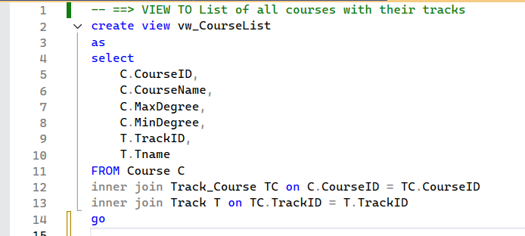
Purpose: The vw_CourseList view provides a consolidated list of all courses available in the system along with the tracks they belong to. Since each course can be associated with one or more tracks through the Track_Course relationship table, this view simplifies the retrieval of course and track details in a single query.
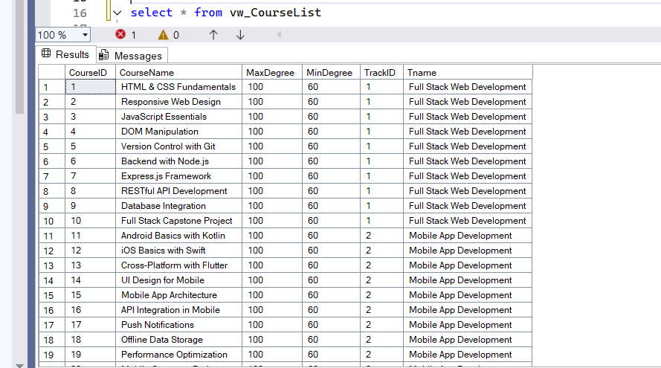
Run query:
View: vw_IntakeTracks
Purpose: The vw_IntakeTracks view provides a combined list of intakes and their associated tracks. Since each intake can offer multiple tracks (and each track can be available in multiple intakes), this view simplifies retrieving all relevant intake and track details in a single query.
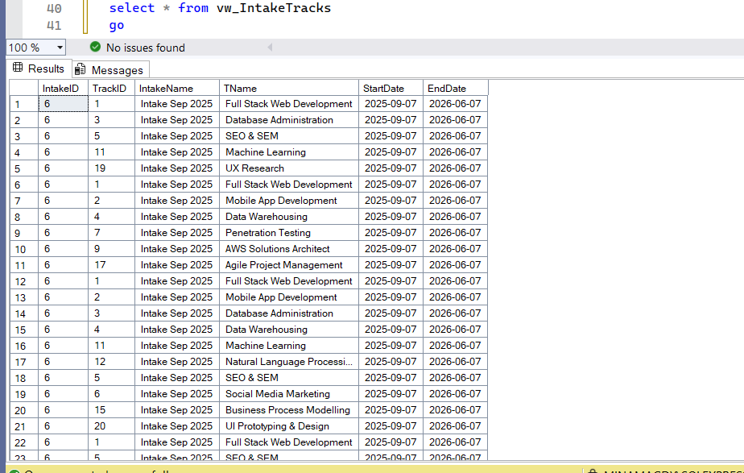
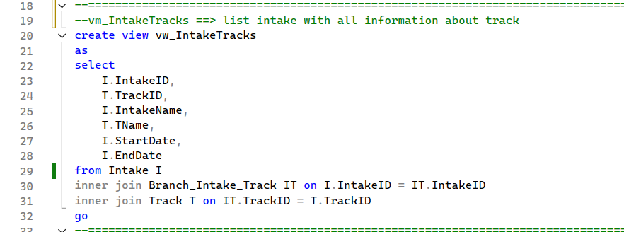
Run query:

View: vw_ExamSchedule
The purpose of the vw_ExamSchedule view is to provide a centralized and simplified way to retrieve information about all upcoming exams in the system. This view helps administrators, instructors, and students by:
Listing scheduled exams with their type, degree, duration, and timing.
Linking each exam to its course for better context.
Displaying the instructor’s details responsible for the exam.
Ensuring only future exams are shown (WHERE StartTime > GETDATE()) so users focus on relevant schedules.
Preventing duplicate records through grouping by exam attributes.
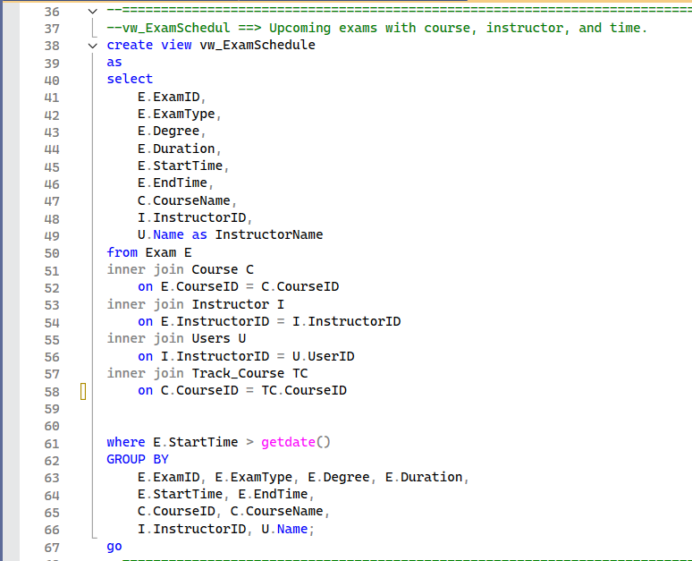

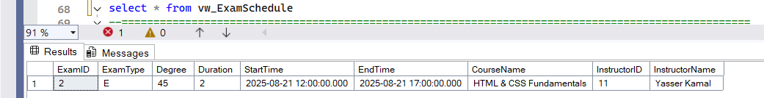
Run query:

View: vw_DepartmentList
The purpose of the vw_DepartmentList view is to provide a consolidated list of all instructors along with their associated department and the courses they teach.
This view is especially useful for administrators and department heads who need a clear overview of teaching assignments across departments.
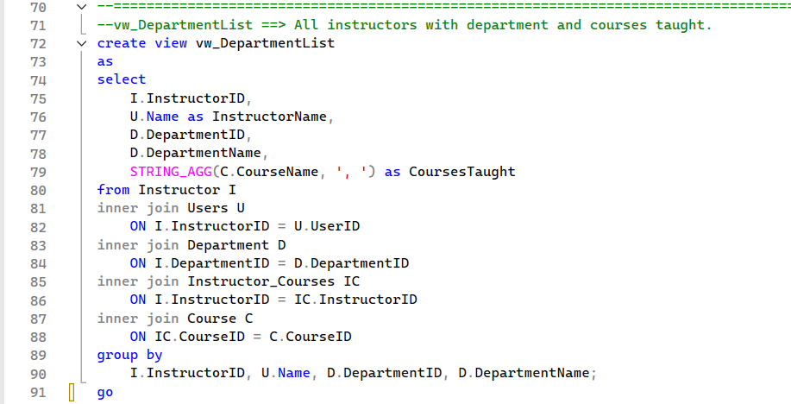
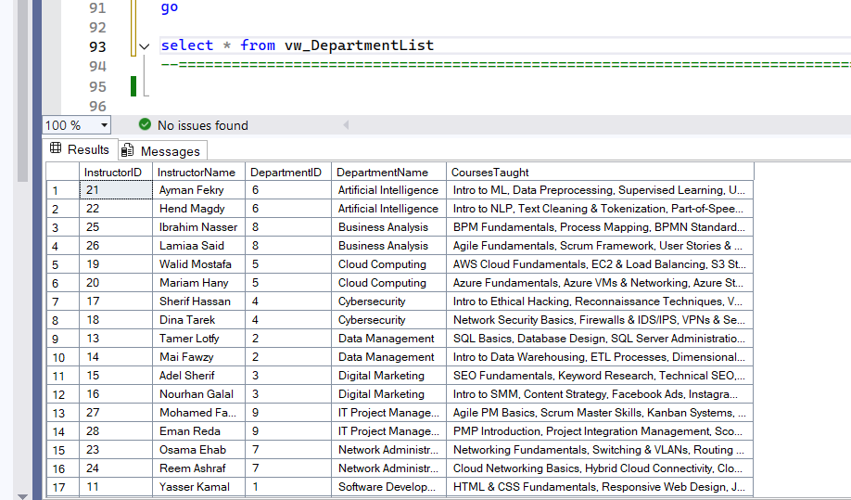
Run Query:
Functions: fn_BranchDetails
Purpose: The function fn_BranchDetails is a table-valued function designed to return comprehensive details about a specific branch when provided with a BranchID. this function accepts a branch identifier as a parameter and dynamically returns all relevant information about that branch, including manager details, intake schedules, and tracks offered.
Key Features:
Branch Information: Displays core branch details such as name, address, and phone number.
Manager Information: Retrieves manager details (ID, name, email, phone) linked to the branch.
Intake Information: Includes intake IDs, names, start dates, and end dates for intakes associated with the branch.
Track Information: Shows the tracks available within the branch’s intakes.
Dynamic Querying: Returns results only for the branch passed into the function.
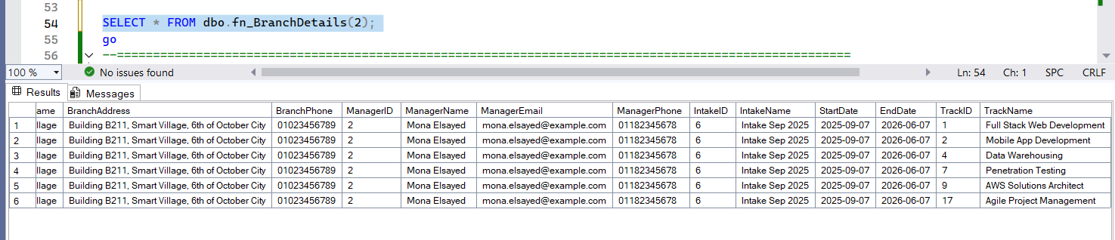
Run Query:

The Query:
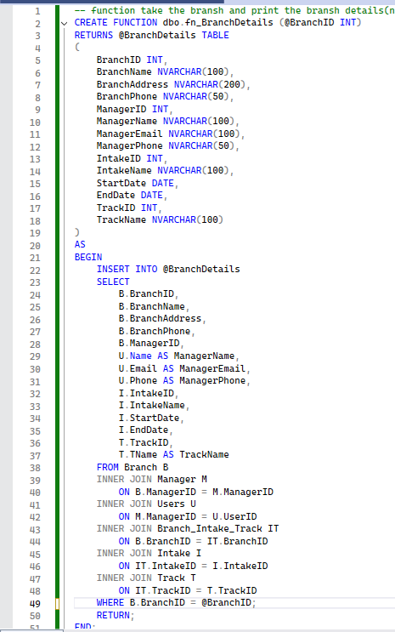

Functions: fn_IntakeTracks
Purpose: The function fn_IntakeTracks is a table-valued function that returns all tracks available in a specific intake within a specific branch. It requires both an IntakeID and a BranchID as input parameters, ensuring the results are scoped to the correct intake–branch combination.
This function provides a flexible, parameter-driven way to retrieve track information compared to static views.
Key Features
Tracks by Intake & Branch: Returns only the tracks offered in the given intake within the specified branch.
Comprehensive Details: Each result row includes TrackID, TrackName, IntakeID, IntakeName, BranchID, and BranchName.
Parameterized Filtering: Ensures the function only retrieves data for the intake and branch provided as input.
Supports multi-branch / multi-intake systems: Useful in cases where the same intake may exist in multiple branches with different tracks.
Run Query:
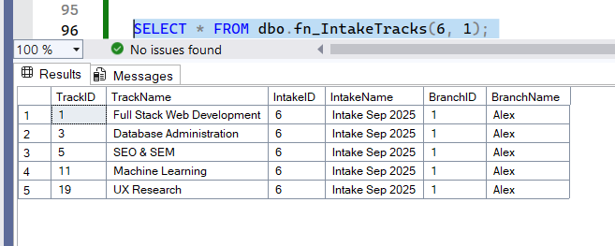

The Query:
